Cairo university

**CS251 - Software Engineering I**

Parking Garage Application

Software Requirements Specifications (SRS)

|  |  |  |  |
| --- | --- | --- | --- |
| **ID** | **Name** | **Email** | **Mobile** |
| 20201203 | Nourhan Amr Abd El Wahab Fathy | noramr318@gmail.com | 01060214271 |
| 20201189 | Nada Emad Mohamed Abd El Aal | nadaemad011@gmail.com | 01103041578 |
| 20200580 | Nagi Mohamed Nagi | mohamednagi903@gmail.com | 01029200874 |
| 20200074 | Esraa Saeed Abdel-samie | mailto:esraasaeed8989@gmail.com | 01158734189 |

**Document Purpose and Audience**

**What this document is?**

İt's a software requirements specification for a parking garage system

**Who is expected to read it?**

Other students. Our professor, and our TA

**Systems Models**

**I. Class Diagram**

**Class Description**

|  |  |  |
| --- | --- | --- |
| **Description & Responsibility** | **Class Name** | **Class ID** |
| **Description:**   * specialized class for all information related to the garage   **Responsibility:**   * holds the attributes of the garage | Garage | 1 |
| **Description:**   * specialized class for all information related to the vehicle   **Responsibility:**   * holds the attributes of the vehicle | Vehicle | 2 |
| **Description:**   * A specialized Controller for the garage class   **Responsibility**   * responsible for all methods related to the garage | Garage Controller | 3 |
| **Description:**   * A specialized interface for calculating the Vehicle Fees   **Responsibility:**   * responsible for Calculating total fees | Calc | 4 |
| **Description:**   * An interface for the configuration of the parking way   **Responsibility:**   * responsible for the configuration or the approach chosen for the park-in function | Configuration | 5 |
| **Description:**   * A class for calculating the fees in a define way which implements from the Calc interface   **Responsibility:**   * Calculates the Vehicle fees with a Five hours rate | FiveHrsRateFees | 6 |
| **Description:**   * A class for parking the car in the first come first served configuration and which implements from the Configuration class   **Responsibility:**   * Parks the vehicle in the first come first served approach and returns the slot index | FirstComeApproach | 7 |
| **Description:**   * A class for parking the car in the best fit configuration and implements from the Configuration class   **Responsibility:**   * Parks the vehicle in the best-fit approach and returns the slot index | BestFitApproach | 8 |
| **Description:**   * specialized class for calculating time   **Responsibility:**   * Catch the time of parkin and park out automatically | Time Controller | 5 |
| **Description**:   * class for the slot’s dimensions   **Responsibility**:   * store the dimensions of every slot in the garage | Slot | 6 |

**II.Sequence Diagrams**

**Park In**

**Park Out**

**Calculate Income**

**Singleton**

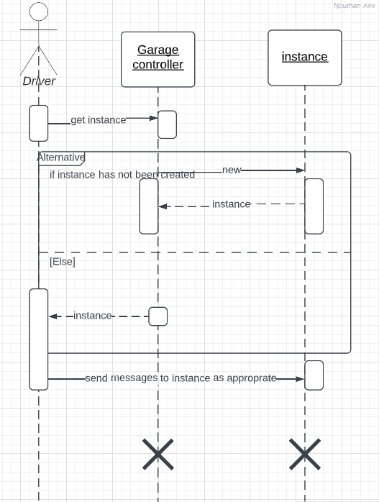

|  |  |  |  |
| --- | --- | --- | --- |
| | **Overall used methods** | | --- | | **Sequence Diagrams** | **Class Name** |
| Get total income  parkin  get Instance  WasItTaken | 1-park in  2-park out  3-singleton  4-calculate income | Garage Controller |
| getTotalIncome, set Info, | 1-park out  2-calculate income | Garage |
| Calculate total time | 1-park in  2-park out | Time Controller |
| parkin, park Out, calculateTotalFees | 1-park in  2-park out  3-calculate income | Vehicle |
|  |  |  |
|  |  |  |
|  |  |  |
| config | 1-park in | Configuration |
| config | 1-park in | BestFitApproch |
| config | 1-park in | FristFitApproch |